1. In this assignment, data was provided for viable cell count and glucose/lactic acid concentration for a fermentation reaction. Six experiments were conducted for reactions at a pH 6.0 , and another six experiments were conducted for reactions at a pH 4.3. This raw data was converted to mean values and standard deviations for each data point, and plots were created for each pH experiment based on mean values and standard deviations.

There was only one outlier found in the data. This point had a glucose concentration [mg/mL] more than 2X the standard deviation outside of the six point data set, so it was disregarded, and the mean value for that data set was recalculated.

1. Here are the final graphs for the fermentation reactions

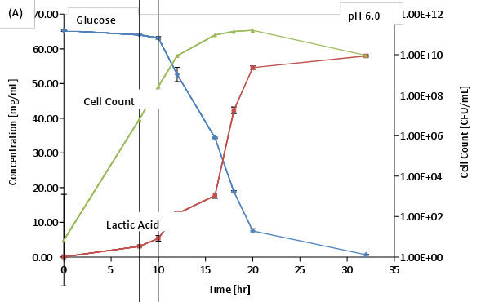

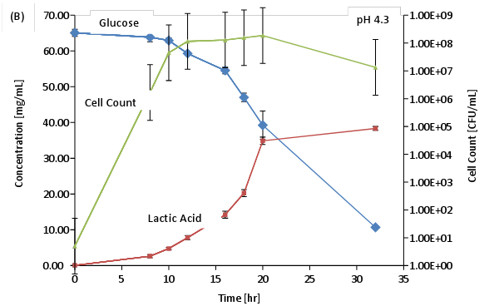

**Figure 1**: Mean values for glucose (●) and lactic acid (■) concentrations plotted against left major axis. Mean Values for viable cell counts (▲) plotted against right major axis on logarithmic scale. Experiment (A) was performed at pH 6.0 and experiment (B) at 4.3 – with *Lactococcus lactis*. Means and standard deviations were taken from six fermentation experiments.

1. Here is the table showing the means and standard deviations for each time point at each pH studied.

**Table 1**: Means and standard deviation for each time point for pH 6.0 and pH 4.3. Glucose and lactic acid concentrations are shown as well as viable cell counts.

|  |  |  |  |
| --- | --- | --- | --- |
|  | pH 6 | | |
| Time [hr] | Glucose Concentration  [mg/mL] | Lactic Acid Concentration  [mg/mL] | Viable Cell Counts [CFU/mL] |
| 0 | 65.28 ± 0.26 | 0.07 ± 0.08 | 5.83 ± 2.07 |
| 8 | 64.03 ± 0.18 | 3.07 ± 0.23 | 1.75E+06 ± 2.81E+04 |
| 10 | 63.15 ± 0.38 | 5.38 ± 0.81 | 5.24E+07 ± 3.20E+05 |
| 12 | 52.62 ± 2.07 | 12.48 ± 0.55 | 1.31E+09 ± 4.78E+07 |
| 16 | 34.36 ± 0.22 | 17.68 ± 0.74 | 1.14E+10 ± 3.12E+08 |
| 18 | 18.85 ± 0.28 | 42.27 ± 0.96 | 1.65E+10 ± 3.43E+08 |
| 20 | 7.55 ± 0.57 | 54.60 ± 0.49 | 1.86E+10 ± 2.88E+08 |
| 32 | 0.65 ± 0.13 | 57.97 ± 0.34 | 1.36E+09 ± 3.37E+07 |

|  |  |  |  |
| --- | --- | --- | --- |
|  | pH 4.3 | | |
| Time [hr] | Glucose  Concentration  [mg/mL] | Lactic Acid Concentration  [mg/mL] | Viable Cell Counts [CFU/mL] |
| 0 | 65.08 ± 1.01 | 0.07 ± 0.08 | 5.02 ± 2.78 |
| 8 | 63.85 ± 1.28 | 2.63 ± 0.43 | 1.66E+06 ± 2.27E+04 |
| 10 | 62.95 ± 0.68 | 4.75 ± 0.32 | 4.49E+07 ± 2.02E+06 |
| 12 | 59.30 ± 0.49 | 7.80 ± 0.57 | 1.15E+08 ± 2.80E+06 |
| 16 | 54.55 ± 0.94 | 14.22 ± 0.96 | 1.28E+08 ± 4.82E+06 |
| 18 | 47.03 ± 1.20 | 20.25 ± 0.99 | 1.56E+08 ± 4.06E+06 |
| 20 | 39.25 ± 3.97 | 34.88 ± 1.04 | 1.87E+08 ± 3.52E+06 |
| 32 | 10.69 ± 0.33 | 38.35 ± 0.54 | 1.34E+07 ± 3.38E+05 |

**Conclusion**: Based on the experimental means, it appears that glucose concentrations are lower on average over time with pH 6.0 (compared to pH 4.3), lactic acid concentrations are higher on average over time with pH 6.0, and viable cell counts are larger on average with pH of 6.0. Thus, the breakdown of glucose is more efficient at a pH of 6.0.